Share these stories about how giving to your local United Way is making an impact!

#1 –
Feeding a family of five is challenging for one local grandma, caring for her son and three grandchildren. With the support of local programs, she doesn’t have to choose which needs she’ll be able to meet this month. “Although she works fulltime, her income only barely meets her needs. She was able to get help with 56 meals this year, freeing up her food budget for things like toilet paper and car repairs.” – Healthy Generations, program receiving funding by your local United Way.

Help families keep food on the table by making a gift to our local United Way.

Image to go with content:

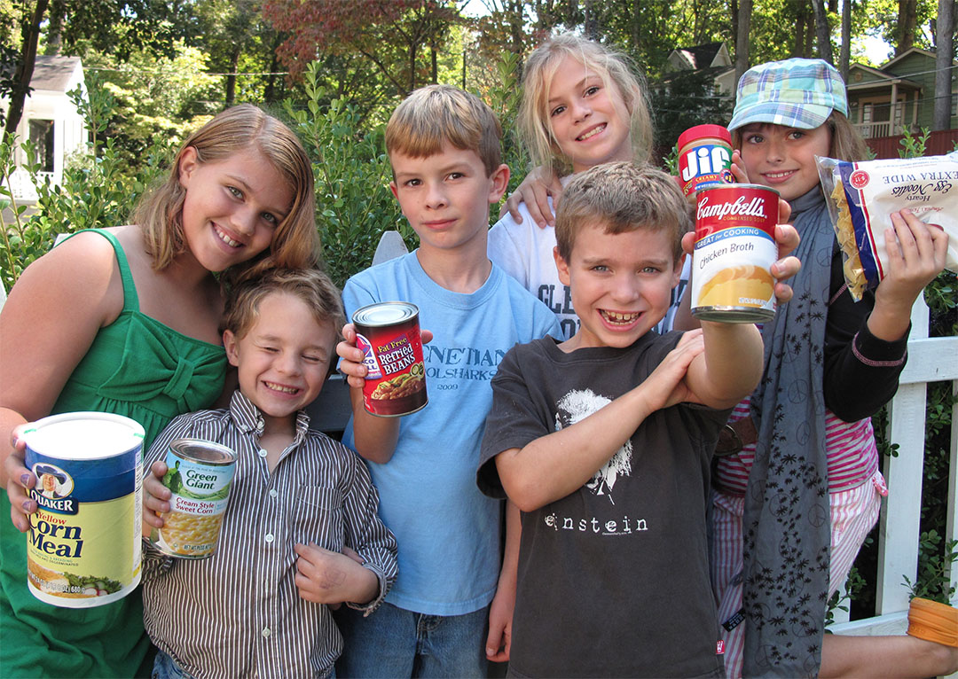

Share these stories about how giving to your local United Way is making an impact!

#2 –
The pandemic has widened the learning gap for local children. Kids who were struggling in the classroom are having a harder time keeping up. Local programs work with students individually to rebuild confidence in the classroom. “Abdullah’s biggest hurdles were understanding his assignments, and he needed individual support. Since then, his grades have been improving along with his attitude towards homework, and willingness to ask questions”. – Mentoring for Youth At-Risk, program receiving funding by your local United Way.

Help kids overcome their learning gap by making a gift to our local United Way.

Image to go with content:

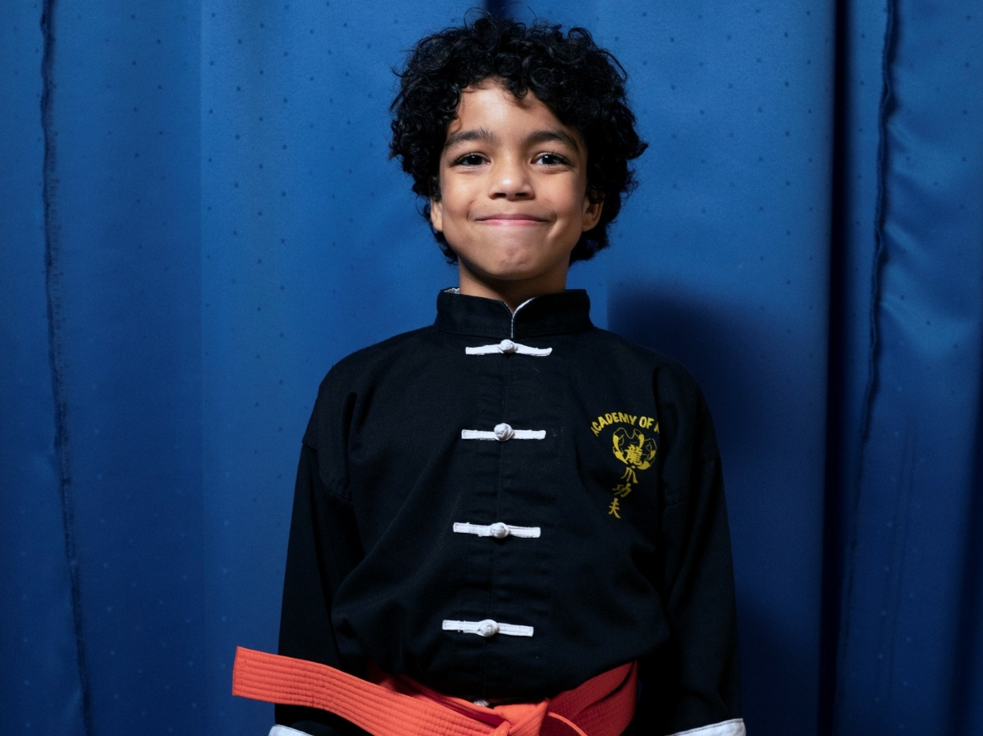

Share these stories about how giving to your local United Way is making an impact!

#3 –
Local children need help growing. Elliot had a difficult time keeping up with the kids on the playground, until his family was able to receive support from a local program. “Elliot was struggling to keep his balance and has had a hard time communicating his needs. Today, he enjoys running around with his friends, climbing the kids rock wall, and his speech has had a boom in growth. You can’t imagine how helpful everything has been!” – local family taking part in a program receiving funding by your local United Way.

Help kids prepare for their future by making a gift to our local United Way.

Image to go with content:
